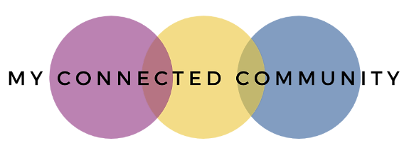
Phone: 0422 85 07 08
Email: enquiries@myconnectedcommunity.com.au
Client Referral Form
CLIENT DETAILS
Date of referral
CLIENT NAME
Preferred Name |  | NDIS Number
Gender Identity |  | Date of Birth
Residential Address
Postal Address
Living Arrangements
e.g., independent, supported
Cultural background |  | Primary language spoken at home
School/Workplace location |  | School/Workplace contact
NOMINEE CONTACT DETAILS
Nominee Name |  | Nominee Relationship
Nominee Phone |  | Nominee Email
Preferred contact method for Nominee |  | Phone | Text |  | Email
CONTACT DETAILS FOR CLIENT (if separate to nominee)
Client Phone |  | Client Email
Preferred contact method for Client |  | Phone | Text |  | Email
SECONDARY CONTACT (EMERGENCY)
Name |  | Relationship
Phone Number |  | Email

NDIS INFORMATION
Diagnosis
Plan Dates
SELF MANAGED – Send invoices to: |  | PLAN MANAGED – Send invoices to:
SERVICE REQUIREMENTS
Location EG: home, kindergarten, community location
Frequency EG: weekly / fortnightly
Preferred time or day for sessions
CLIENT GOALS
Please outline the focus for support. Please forward (or attach) a copy of NDIS plan goals.

REFERRER DETAILS
Name |  | Organisation/Role
Phone Number |  | Email
To ensure we are aware of factors which may impact service provision, please share relevant details below
Is there a current/active Behaviour Support Plan for the participant?  **A copy will be required prior to service. |  |  |  | YES ☐ | NO ☐
Are there any current/active court orders in place?  **A copy may be required prior to service. |  |  |  | YES ☐ | NO ☐
Potential environmental issues for staff visiting the home? |  |  |  | YES ☐ | NO ☐
Does the participant have any personal care requirements? |  |  |  | YES ☐ | NO ☐
Does the participant have any alternative communication requirements? |  |  |  | YES ☐ | NO ☐
Does the participant have any mobility requirements? |  |  |  | YES ☐ | NO ☐
Does the participant have any medical conditions we should be aware of? |  |  |  | YES ☐ | NO ☐
Are there any other factors we should be aware of prior to meeting with the participant? |  |  |  | YES ☐ | NO ☐
Please add any further comments or information if relevant:

Please email the completed form to enquiries@myconnectedcommunity.com.au

